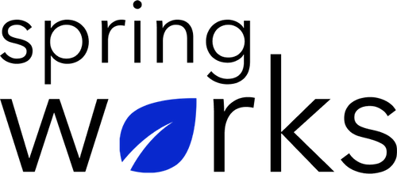
Free Template – Employee Retention Survey

Use this survey to understand your employees’ needs and motivation better.

Employee retention surveys are crucial for improving employees’ performance and reducing the company’s turnover rate. Copy this template to your Google Drive and customize it for your organization.

Communication (to be added as review instructions):

Your responses to this survey are anonymous. The leaders are committed to analyzing your results and taking action. Please answer this quick survey by <HOUR OF THE DAY> on <DATE>.

Thank you for your time. Your responses will help our organization become a better place to work. If you have any questions about the survey, please contact [insert name of contact person].

Demographic Information:

The following information is requested so that meaningful analysis and comparisons of group results can be made. Please check the circle corresponding to your answer.

Q: Your Gender:

- Male
- Female

Q: Your Department:

- Marketing
- Operations
- Tech
- Accounting
- HR

Q: Company Service:

- Under 1 Year
- 1-2 Year
- 3-5 Year
- 6-10 Year
- 10-15 Year
Employee Retention Questionnaire

To answer clearly what you think or feel about each item, please follow these steps:

- Read each item fully before you start to mark your answer.
- Pick the one answer which most nearly says what you think or how you feel.
- While completing the questions, be sure to read the special instructions which are included.

Choose the most appropriate answer:

Q: I feel like I am able to reach my full potential at this organization:

- Strongly agree
- Agree
- Neutral
- Disagree
- Strongly disagree

Q: I feel comfortable working with my teammates:

- Strongly agree
- Agree
- Neutral
- Disagree
- Strongly disagree

Q: I have a clear understanding about my career path and promotion plan:

- Strongly agree
- Agree
- Neutral
- Disagree
- Strongly disagree

Q: I know what is expected of me in my job:

- Strongly agree
- Agree
- Neutral
- Disagree
- Strongly disagree

Q: I like going to work:

- Strongly agree
- Agree
- Neutral
- Disagree
- Strongly disagree

Q: I feel like my feedback is valued:

- Strongly agree
- Agree
- Neutral
- Disagree
- Strongly disagree

Q: I can see myself working here in a year:

- Strongly agree
- Agree
- Neutral
- Disagree
- Strongly disagree

Q: I am happy with the amount of recognition I receive from my manager and peers:

- Strongly agree
- Agree
- Neutral
- Disagree
- Strongly disagree

Q: I feel that I am paid fairly:

- Strongly agree
- Agree
- Neutral
- Disagree
- Strongly disagree

Q: Do you feel like you are reaching your full potential with this position? If not, what would make you feel that way?

Q: If you were to accept a job opportunity at another company, what would the main reason be?

Q: If you had to do it all over again, would you apply to this position? Why?

Q: From 1 to 10, how happy are you about your supervisors?

0 | 1 | 2 | 3 | 4 | 5 | 6 | 7 | 8 | 9 | 10

Q: On a scale of 1-10, how likely are you to recommend a job at this company to a friend or family member?

0 | 1 | 2 | 3 | 4 | 5 | 6 | 7 | 8 | 9 | 10

Q: Is there anything else you’d like to add?

Thank you in advance for your candid feedback.

